**AWS and DevOps- Manual Docker Configuration in AWS**

1. Provision EC2 machine using Amazon Linux AMI for Dockers Server.

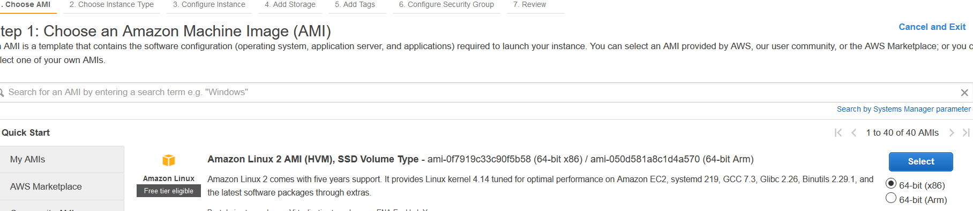

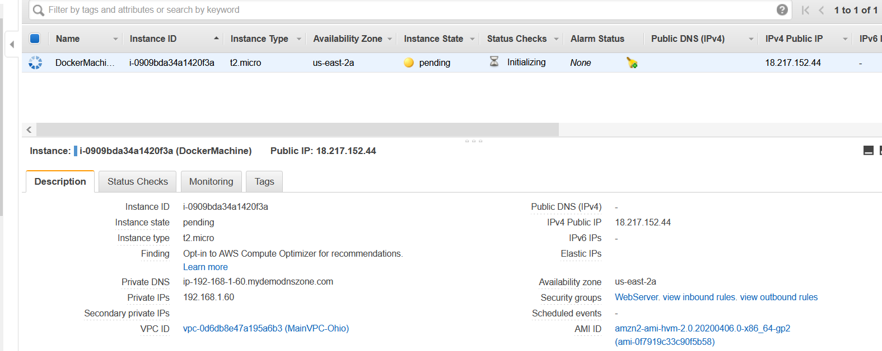

1. Now connect and login to Docker Machine.

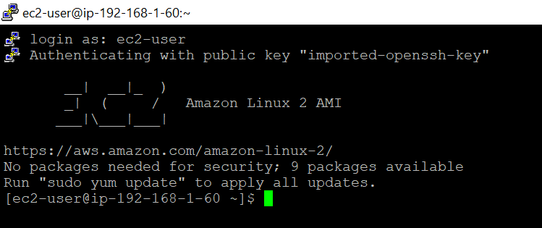

1. Take the root privilege.

Sudo su

Cd

1. Install the docker, since OS on docker machine is Amazon Linux so we will using ‘**yum’ command.**

**Yum update -y**

**Yum install docker**

**Check docker information: docker info**

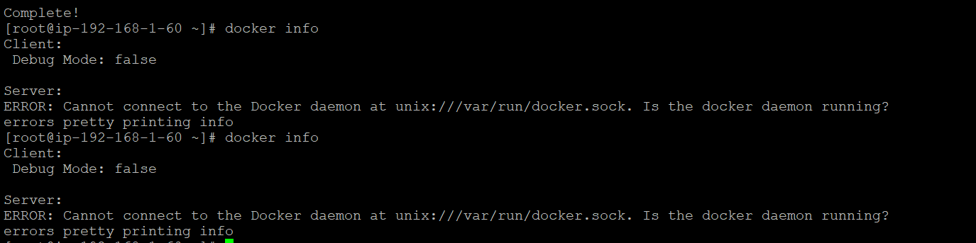

Start the docker daemon: **service docker start**

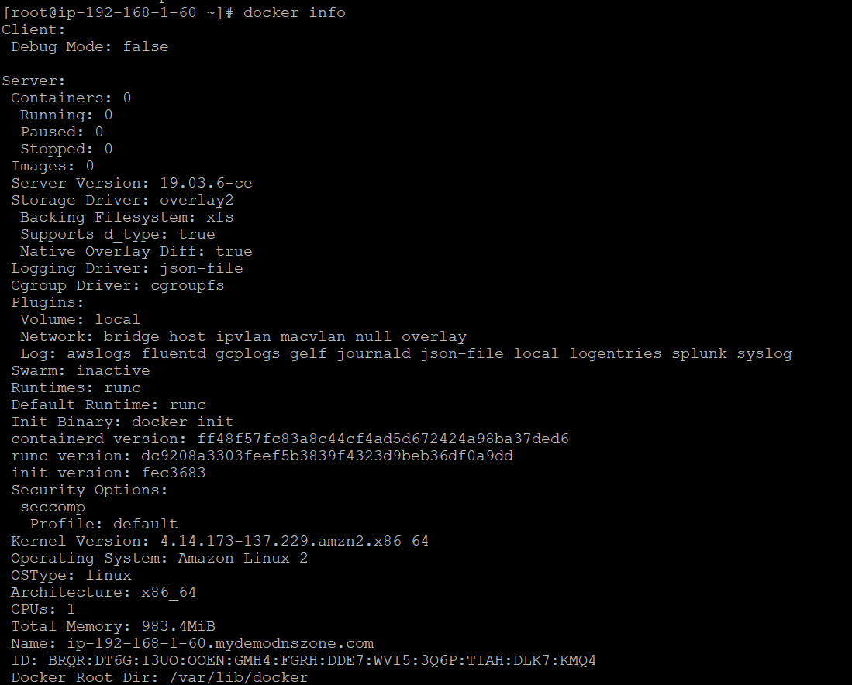

**Now, we can observer docker is installed and running.**

1. **Install git if not installed.**

**Yum install git -y**

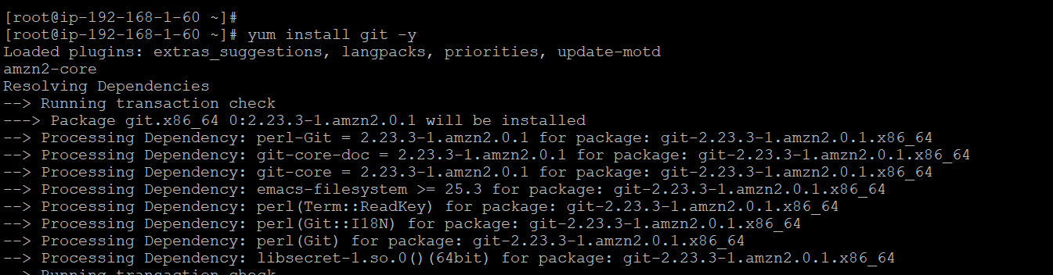

1. **Create Docker Hub Account and Repository if don’t have.**

[**https://hub.docker.com/**](https://hub.docker.com/)

[macrpravesh08 / aws_dhub](https://hub.docker.com/repository/docker/macrpravesh08/aws_dhub)

1. **Build Docker Image, follow following steps:**

* **To Build docker image, create docker file. Search on google sample Docker file.**

**Clone WebApp project on Docker Server(EC2) from below git url which contains Docker file as well.**

[**https://github.com/rampravesh0808/AWSDockerDemoApp.git**](https://github.com/rampravesh0808/AWSDockerDemoApp.git)

* **Git clone** [**https://github.com/rampravesh0808/AWSDockerDemoApp.git**](https://github.com/rampravesh0808/AWSDockerDemoApp.git)

**Can observe that AWSDockerDemoApp is cloned on docker machine and Docker file is available inside.**

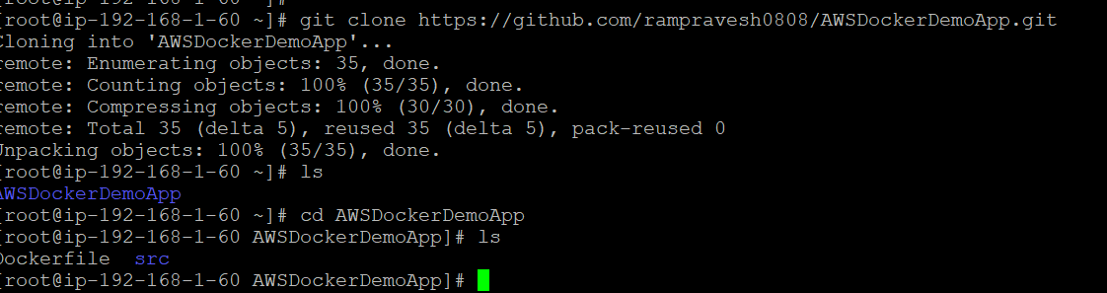

* **Run command to build image: Docker build .**

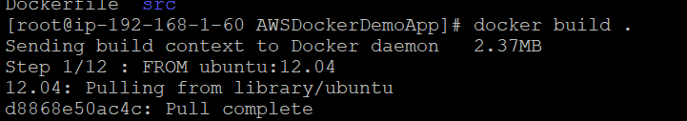

* **Run command to see docker image: docker images**

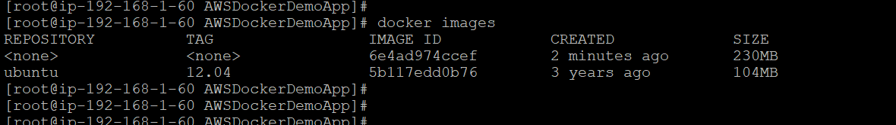

* **Try to run docker image: docker run -p 80:80**

**Observed that it needs argument as repository name where image is stored.**

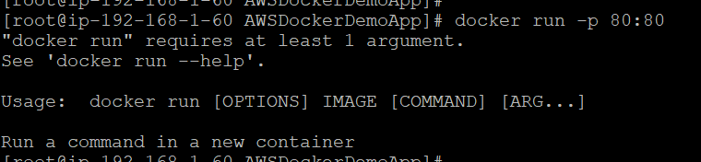

* **Now, build the docker image and provide repository name so that we can run and deploy. Following is command and provide Docker Hub Repository name macrpravesh08/aws_dhub:latest**

**docker build -t macrpravesh08/aws_dhub:latest .**

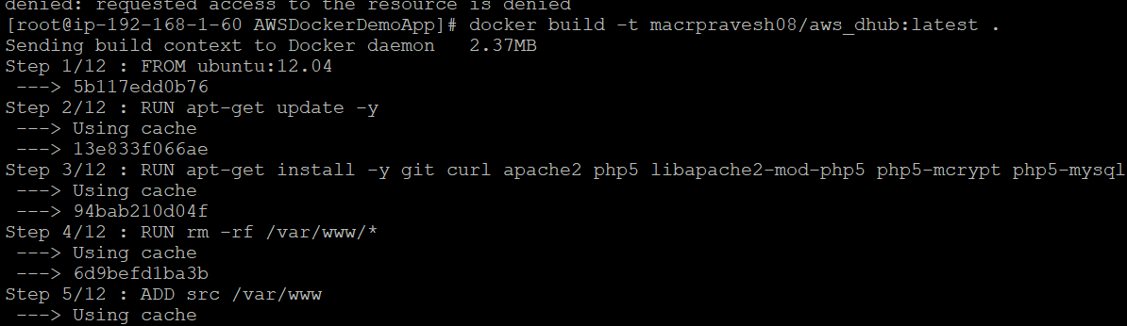

* **Try to push the image to docker hub repository.**

**docker push macrpravesh08/aws_dhub:latest**

Permission denied because, required to login into Docker Hub account on Docker Server(EC2).

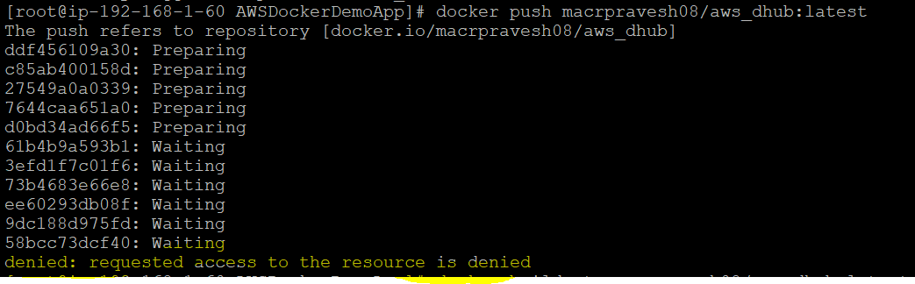

* **Login to docker in EC2 Dcoker Machine**

**Docker login**

**Username**

**Password**

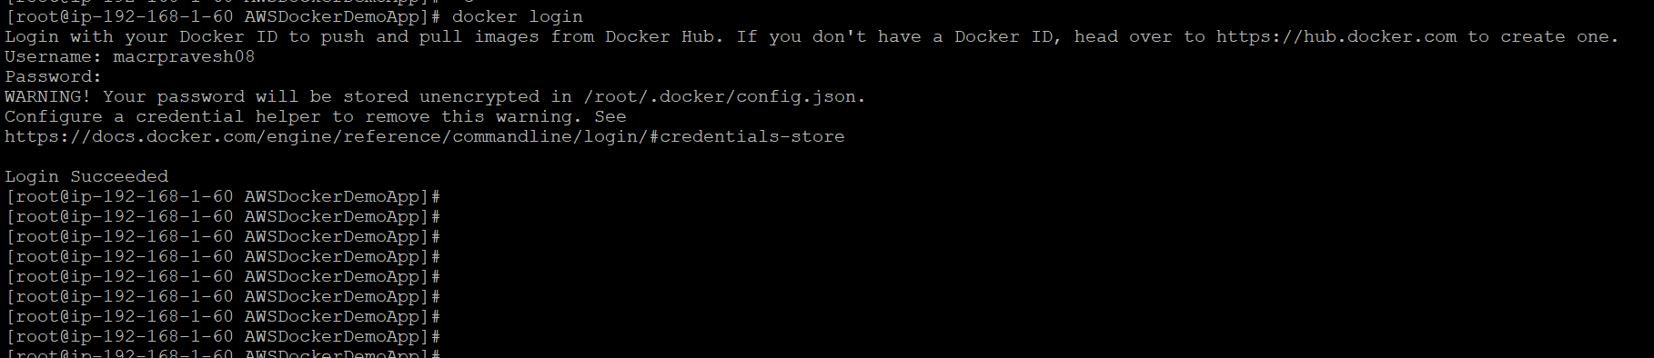

* **Now Push image to docker hub repository.**

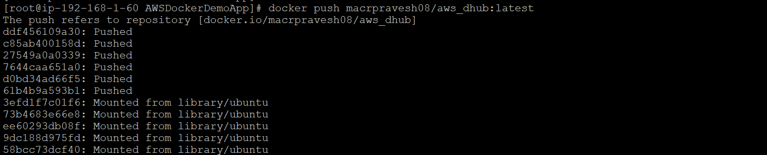

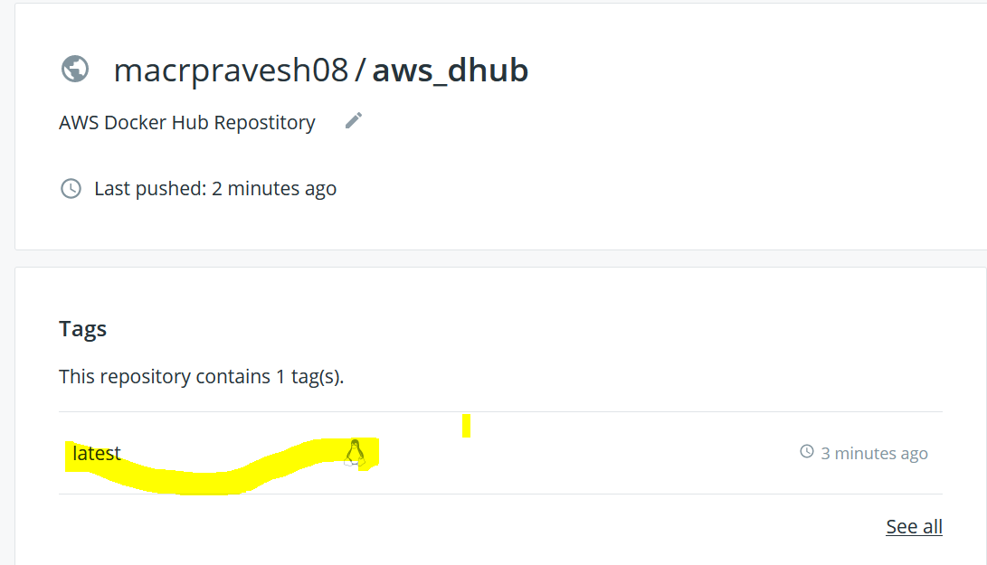

* **Now pull the image from docker hub repository.**

**docker pull macrpravesh08/aws_dhub:latest**

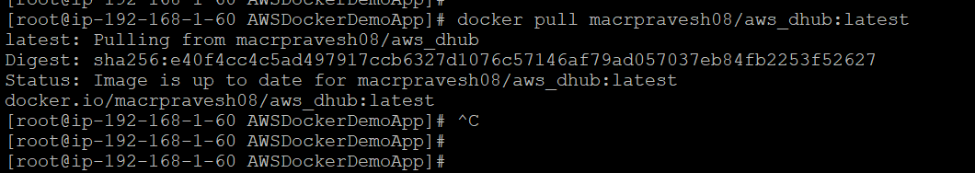

* **Now, Run the Docker Image.**

**docker run -p 80:80 macrpravesh08/aws_dhub:latest**



* **Now, Open public IP. We can see, application is deployed and running on docker container.**

